**Week- 4**

**Name:** Ronit Kumar **Reg:** RA2111032010009 **Section:** T2

1. **Create the below table and execute the insert, update and the below select statements.**

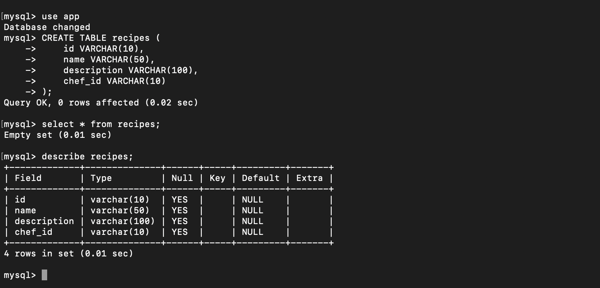

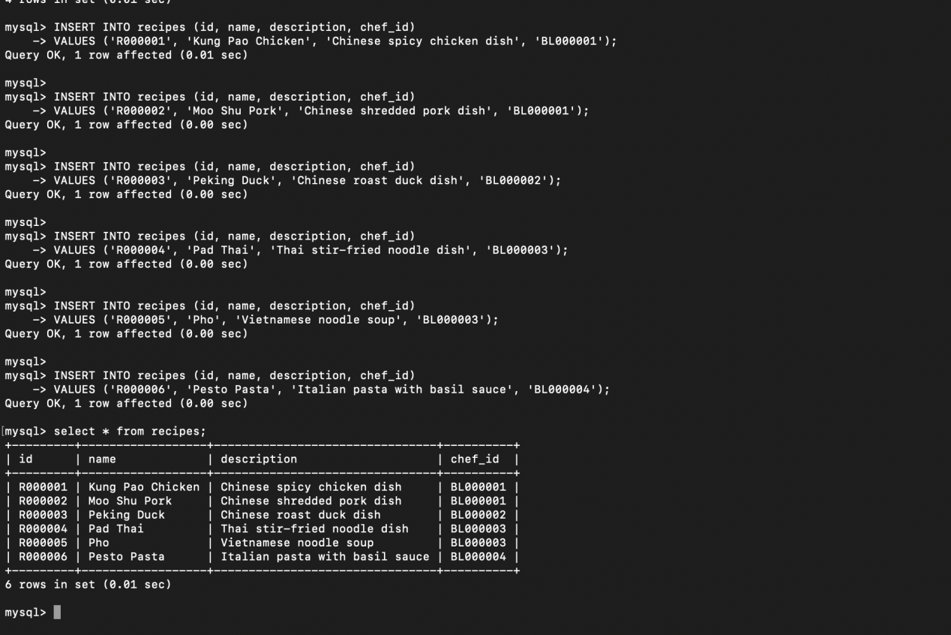

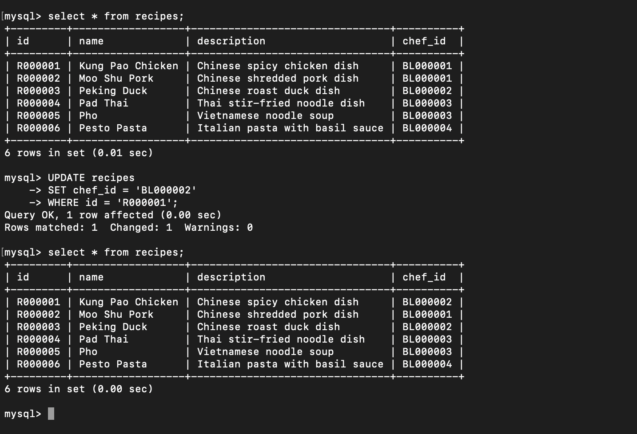

**i) Write a query to display the total number of recipes available with the description**

**“Chinese”**

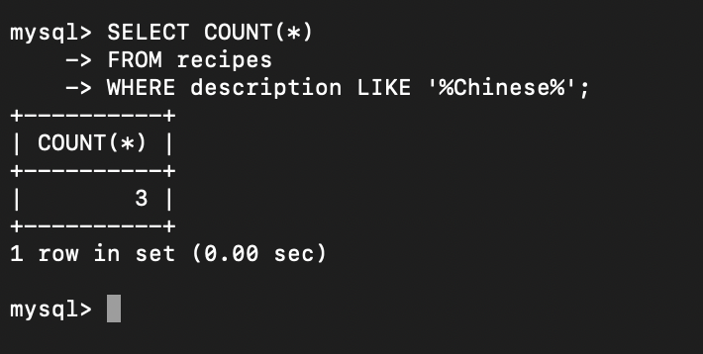

**ii) Write a query to display the id, name of the recipes with chef_id 'BL000002'.**

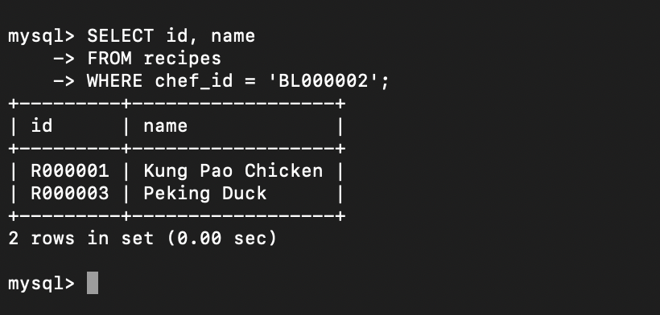

**iii) Write a query to display the description of the recipes whose name begins with 'P'.**

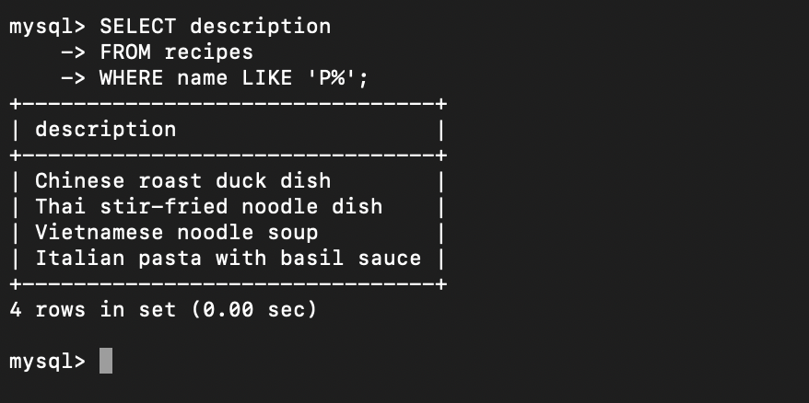

**2. Create a table movie of the below structure and assume data types.Movie_ID,**

**Movie_Name, Genre, Language, Rating ,Do the following queries**

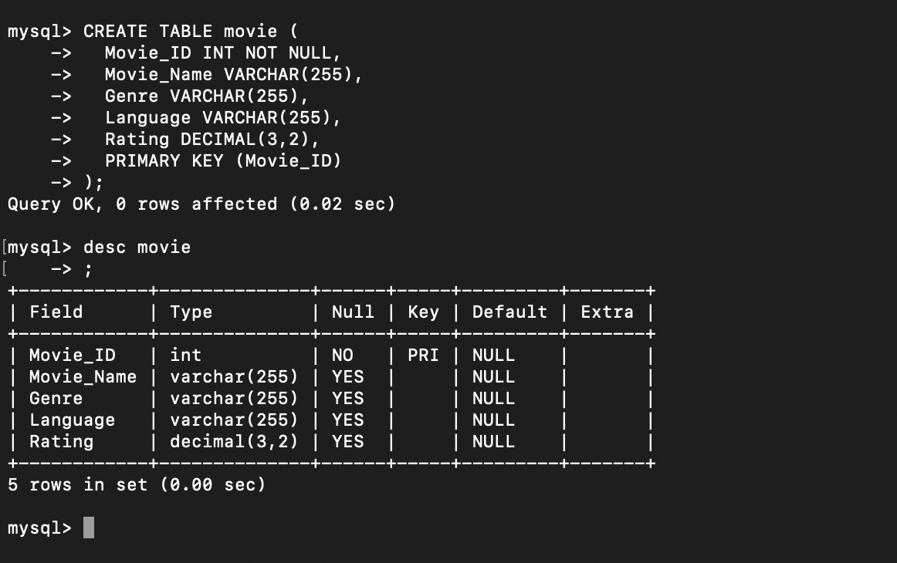

1. **Update the movies rating by 10% and display it**

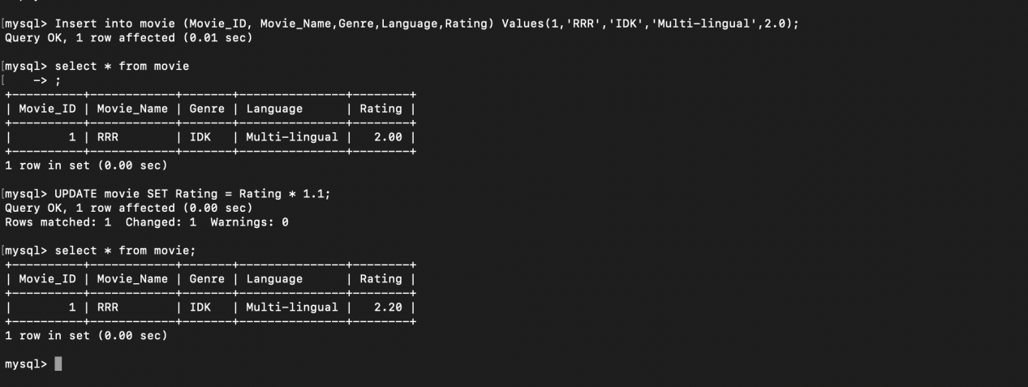

1. **Delete the movies with movie_id 102**

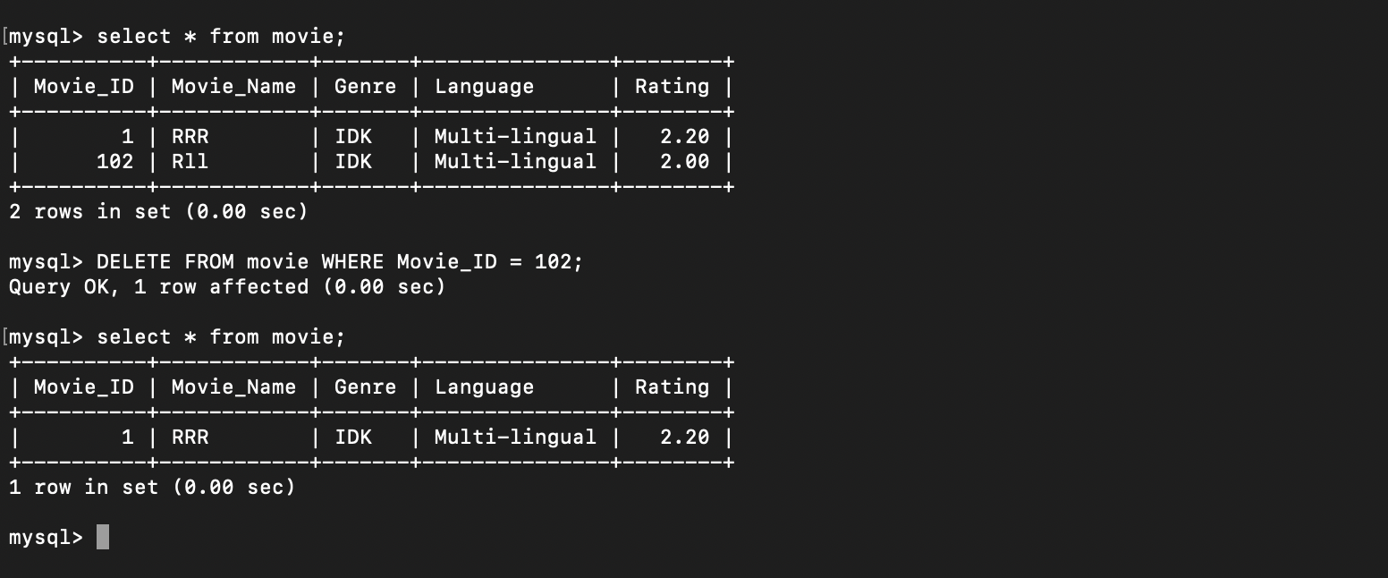

**c. Select movies whose rating is more than 3.**

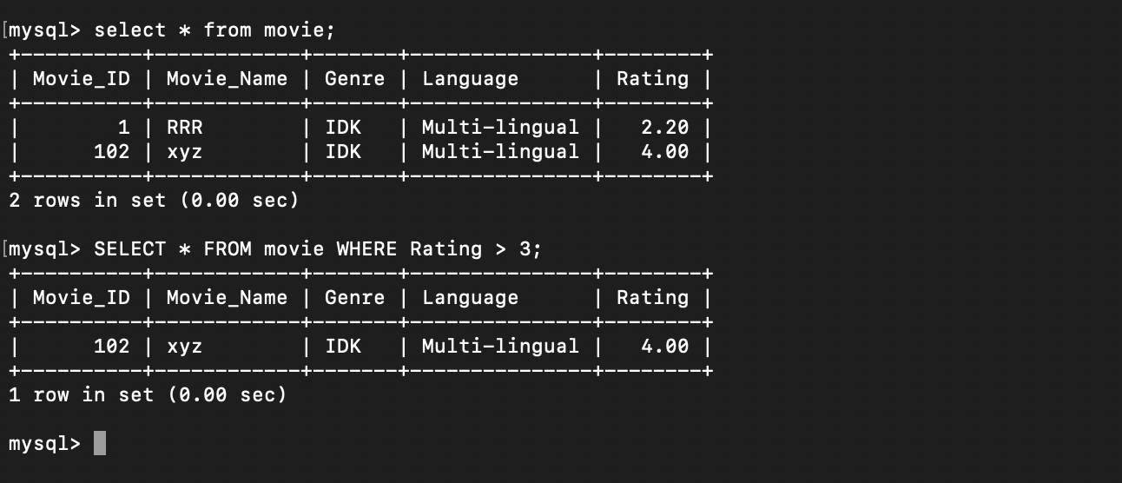

**3. Create a course database with the following fields Product(ID, Prod_name,**

**Supplier_id,Unit_price,Package,OrderID),OrderItem(ID,Order_id,Product_id,Unit_price,**

**Quantity) using Foreign key**

**a. Display the total quantity of every product in the stock**

**b. Sort the Unit_price based on the supplier_id**

**c. Display the Product_name along with order_id and supplier_id**

CREATE TABLE OrderItem (

ID INT PRIMARY KEY,

Order_id INT,

Product_id INT,

Unit_price DECIMAL(10,2),

Quantity INT,

FOREIGN KEY (Order_id) REFERENCES "Order"(Order_id),

FOREIGN KEY (Product_id) REFERENCES Product(ID)

);

CREATE TABLE Product (

ID INT PRIMARY KEY,

Prod_name VARCHAR(255),

Supplier_id INT,

Unit_price DECIMAL(10,2),

Package VARCHAR(50),

OrderID INT,

FOREIGN KEY (Supplier_id) REFERENCES Supplier(ID),

FOREIGN KEY (OrderID) REFERENCES OrderItem(Order_id)

);

INSERT INTO Product (ID, Prod_name, Supplier_id, Unit_price, Package, OrderID)

VALUES (1, 'TABLE', 1001, 500.57, 'PACK1', 'ORD1'),

(2, 'CHAIR', 2002, 250.60, 'PACK2', 'ORD2'),

(3, 'BLACKBOARD', 1003, 1000.99, 'PACK3', 'ORD3');

INSERT INTO OrderItem (ID, Order_id, Product_id, Unit_price, Quantity)

VALUES (1, 'ORD1', 1, 500.57, 20),

(2, 'ORD2', 2, 250.60, 10),

(3, 'ORD3', 3, 1000.99, 35);

**4. Write a SQL lite3 statement to create a table named as job including columns**

**job_id,job_title,Min-salary,Max_salary.job_id column does not contain any duplicate**

**value at the time of insertion**

import sqlite3

conn = sqlite.3.connect(‘app.db’)

print “opened db succesfully”;

conn.execute(‘’’

CREATE TABLE job (

job_id INTEGER PRIMARY KEY,

job_title TEXT NOT NULL,

Min_salary REAL,

Max_salary REAL,

UNIQUE(job_id)

);

’’’)

print “Table created succesfully”;

conn.close()

**5. Write a SQL lite3 statement to create a table names as job_history including columns**

**employee_id, start_date, end_date, job_id and department_id and make sure that, the**

**employee_id column does not contain any duplicate value at the time of insertion and the**

**foreign key column job_id contain only those values which are exists in the jobs table.**

import sqlite3

conn = sqlite.3.connect(‘app.db’)

print “opened db succesfully”;

conn.execute(‘’’

CREATE TABLE job_history (

employee_id INTEGER NOT NULL,

start_date TEXT NOT NULL,

end_date TEXT NOT NULL,

job_id TEXT NOT NULL,

department_id INTEGER NOT NULL,

PRIMARY KEY (employee_id, start_date),

FOREIGN KEY (job_id) REFERENCES jobs(job_id)

);

’’’)

print “Table created succesfully”;

conn.close()